An automated irrigation system using soil moisture and temperature sensors, implemented with Arduino and RF communication at 433 MHz, is an efficient way to manage water usage in agriculture or gardening. Here’s an overview of how you can set up such a system:

**Components Needed**

1. **Microcontroller**: Arduino Uno
2. **Soil Moisture Sensor**: To measure the moisture level in the soil.
3. **Temperature Sensor**: To monitor the ambient temperature (e.g. LM35).
4. **RF Transmitter and Receiver**: 433 MHz modules for wireless communication.
5. **Water Pump**: To control the irrigation.
6. **Relay Module**: To switch the pump or valve on/off.
7. **Power Supply**: Batteries or AC adapter for the Arduino and other components.
8. **Miscellaneous**: Jumper wires and breadboard.

**Working Principle**

1. **Sensors**:
   * The soil moisture sensor continuously measures the moisture content in the soil.
   * The temperature sensor tracks the ambient temperature, which can be useful for decision-making (e.g., watering more during hot days).
2. **Arduino Control**:
   * The Arduino reads data from the moisture and temperature sensors.
   * Based on predefined thresholds, the Arduino decides whether to activate the water pump.
3. **RF Communication**:
   * If you have multiple sensor nodes (e.g., in a large field), each node can send data back to a central controller using the RF transmitter.
   * The receiver collects this data and makes centralized decisions about irrigation.
4. **Irrigation Activation**:
   * When the moisture level falls below a certain threshold (indicating dry soil) and considering temperature conditions, the Arduino activates the relay to turn on the water pump.

**Implementation Steps**

1. **Circuit Assembly**: Connect the sensors and relay module to the Arduino according to their respective pin configurations.
2. **Programming**: Upload the Arduino code, ensuring you have the correct libraries for the sensors.
3. **Testing**: Check the system in a controlled environment to ensure it responds correctly to moisture and temperature readings.
4. **RF Communication**: If using multiple nodes, implement the RF modules to send sensor data wirelessly. Use appropriate libraries (like RadioHead) for handling RF communication.

**Connection Picture and Details**

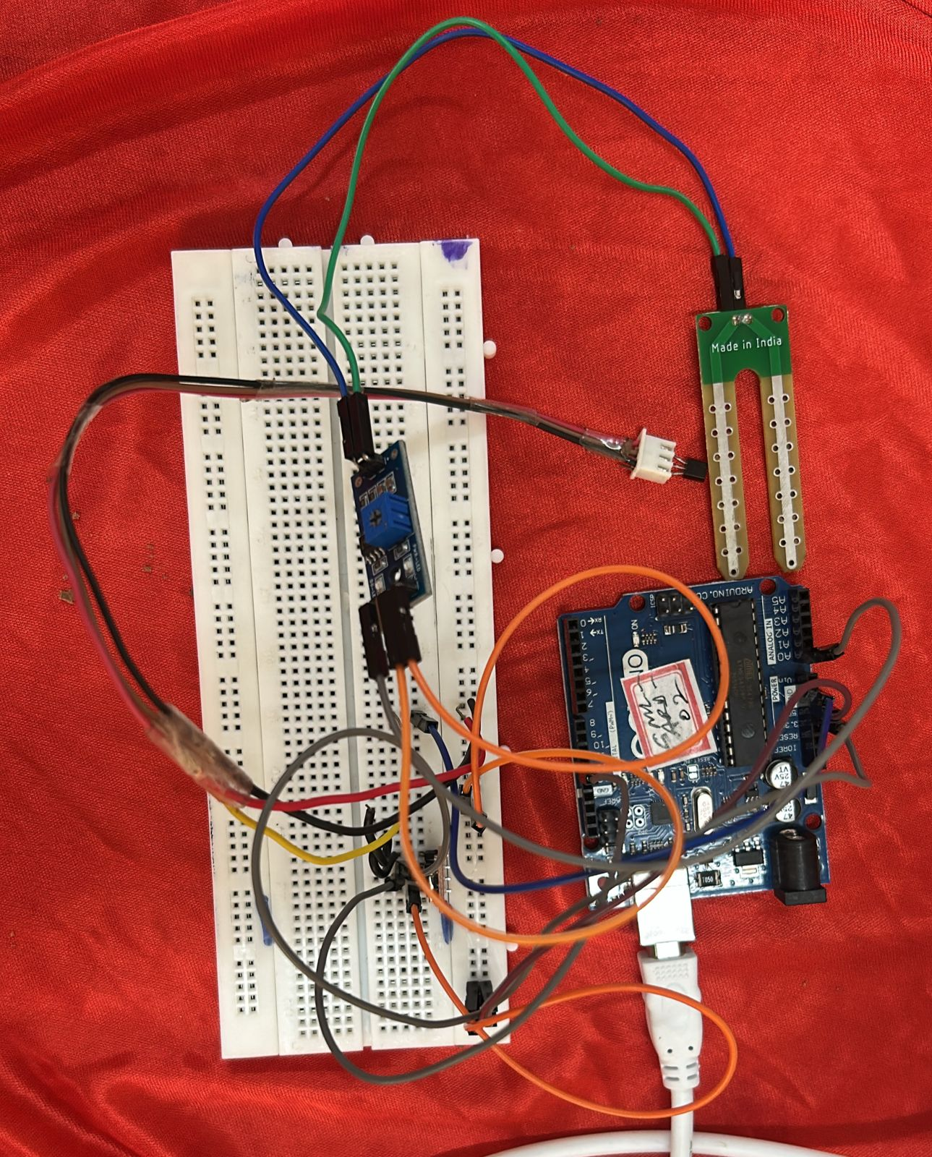

Output of soil moisture sensor – A0

Temperature sensor – A2

Transmitter – 11

Receiver – 12

Output of Relay – 7

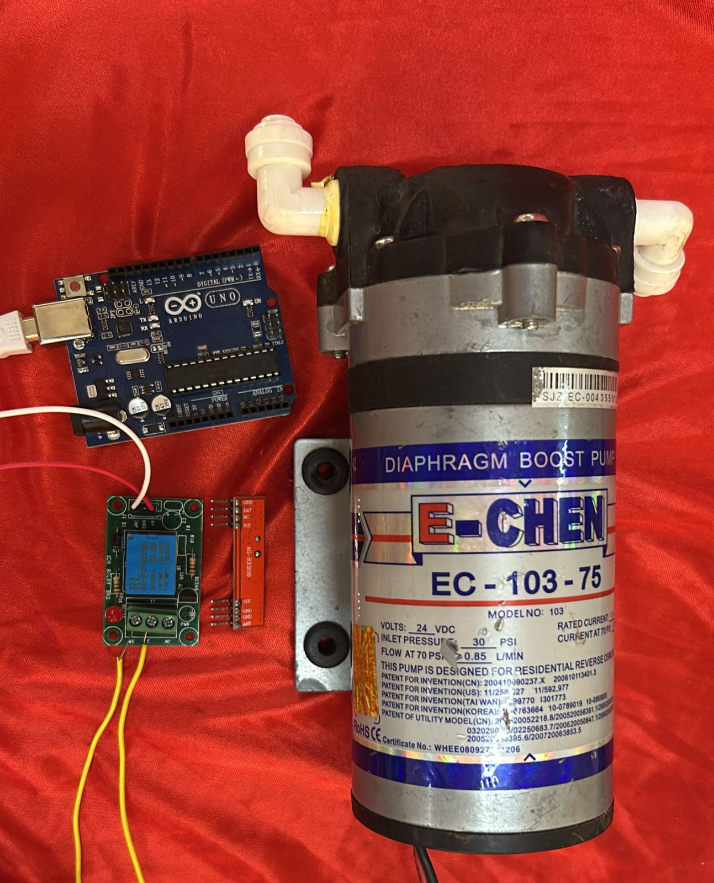

**Advantages**

* **Water Efficiency**: Reduces water wastage by irrigating only when necessary.
* **Automation**: Less manual intervention required.
* **Data Collection**: Helps in monitoring and improving irrigation practices based on collected data.

**1. Soil Moisture Monitoring**

* **Real-time Monitoring:** Continuously measures soil moisture levels to determine the water needs of plants.
* **Threshold Alerts:** Configurable moisture thresholds trigger irrigation when levels fall below a set point.

**2. Wireless RF Communication**

* **Sensor Node Flexibility:** Allows multiple sensor nodes to communicate with the central Arduino controller without needing wired connections.
* **Long-range Capability:** Depending on the RF module used, communication can be effective over significant distances, suitable for large gardens or farms.

**3. Automated Irrigation Control**

* **Drip Irrigation Support:** Can be adapted for specific irrigation methods, like drip or sprinkler systems.

**4.Safety Features**

* **Fail-Safe Mechanisms:** Automatically shuts off irrigation if a fault is detected, preventing overwatering.